Rainwater Harvest (Rajasthan, India)
The negative tipping point in this story was commercial logging concessions granted by the rajahs shortly before India’s independence. A system of vicious cycles was set in motion by the ensuing cascade of effects:

- Logging reduced the forest’s protection of the watershed from soil erosion. Soil erosion and the sediment load in rainwater runoff increased. More sediment was deposited in johad ponds, reducing their capacity to channel water to the aquifer. With less water input to the aquifer, the water table slowly dropped. Trees and other vegetation died when the water table fell beyond reach of their roots. The loss of vegetation led to even more erosion and sediment in the runoff.

- Villagers compensated for the drop in the water table by using tube well technology to dig deeper wells. That lowered the water table even further, forcing the digging of even deeper wells.

- More sediment deposition in the johad required more labor to remove it. This, and the fact that the water supply was shifting to deeper and deeper tube wells, reduced the villagers’ motivation to maintain the johad. As they fell into disrepair, the johad gradually went out of use along with the social institutions and technology for maintaining them.

- Eventually the water table was so low that even the deepest tube wells were drying up. So did the irrigation water necessary for dry-season agriculture. Men moved to cities to find work, leaving villages without the labor supply needed to maintain the johad. This accelerated decline of the johad and depletion of the aquifer even further.

- As can be seen in the diagram below, the four vicious cycles listed above were interconnected and mutually reinforcing. The end result was disappearance of the johad and loss of the local water supplies and village forests. Women and children were cast into a nightmare of walking long distances to collect water and fuel wood. Children had no time for school, and women had little time for other family responsibilities and economic activities.

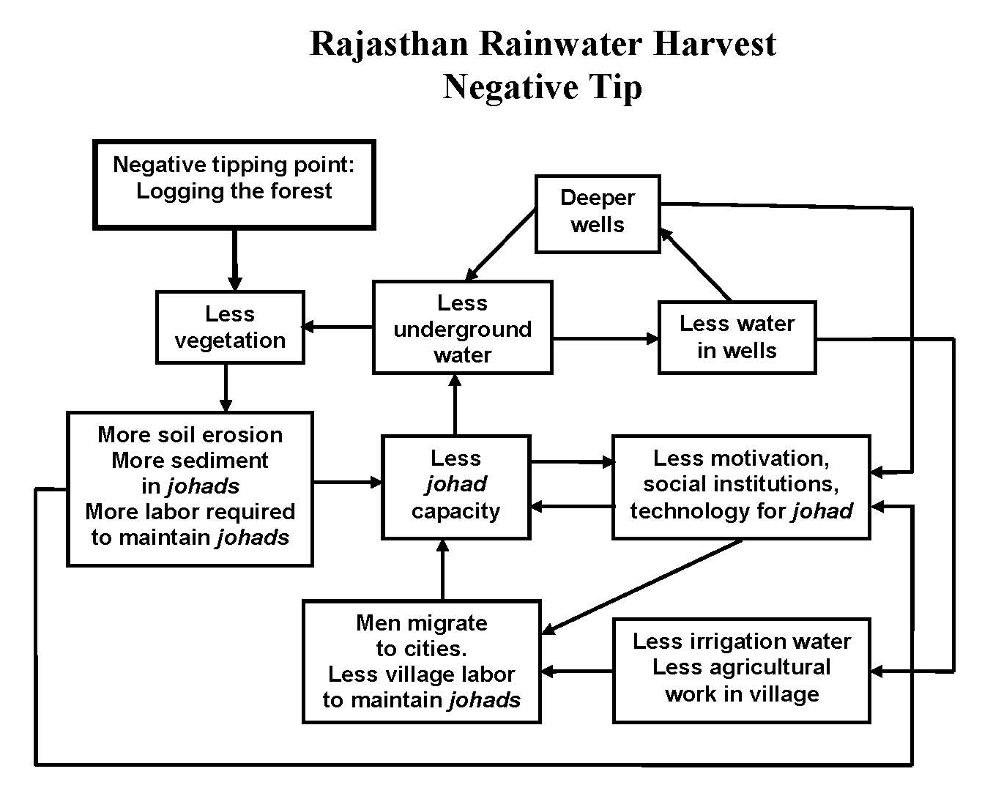

Diagram for students to fill in:
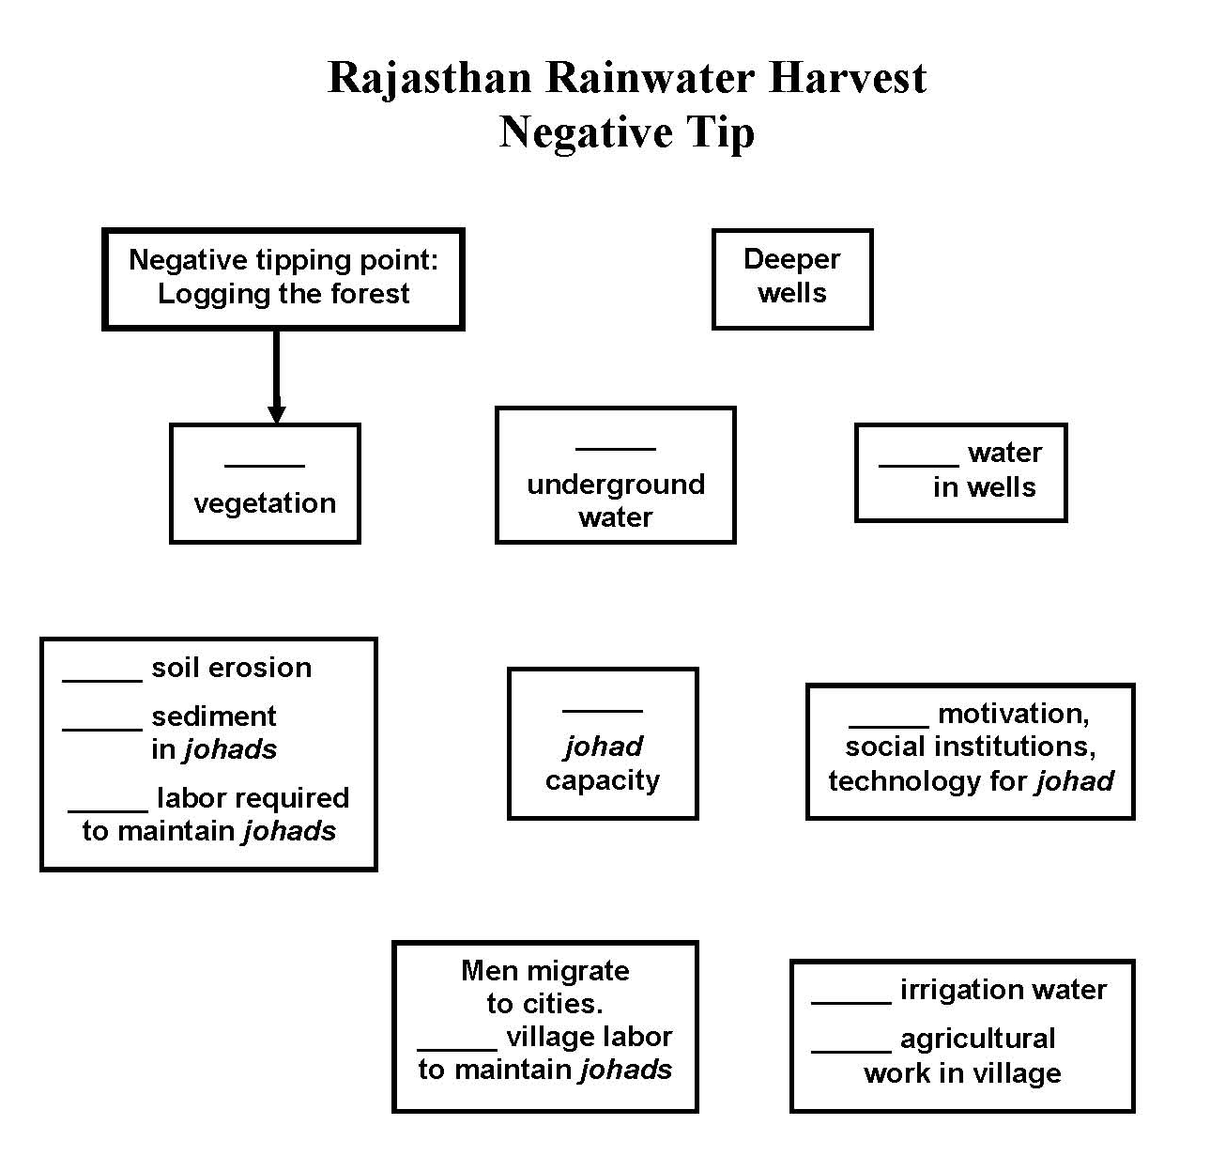
The positive tipping point was the restoration of a single johad in Gopalpura village, along with restoration of the traditional gram sabah village council to manage it. The ensuing cascade of effects reversed three of the feedback loops in the negative tip, transforming the vicious cycles to virtuous cycles:

- Water soon returned to wells near the johad, stimulating the villagers to restore more johad. The technology and social institutions for restoring, maintaining, and building new johad, evolved as more johad were put into service.

- The water table rose, filling more wells and restoring irrigation agriculture. Men moved back to the villages, providing the labor necessary to restore, build, and maintain even more johad.

- With the water table once again close to the surface, the villagers planted trees to restore the village forest. The forest not only provided fuelwood but also reduced soil erosion, reducing sedimentation of the johad and making them easier to maintain.

- The virtuous cycles continued until all village wells were flowing and the village locked into a sustainable water supply. Women and children no longer had to spend long hours getting water and fuelwood. Children returned to school and women returned more attention to family and economic activities. A new virtuous cycle was set into motion when people from other villages heard about the success in Gopalpura and came to see what happened. Johad spread to hundreds of villages.
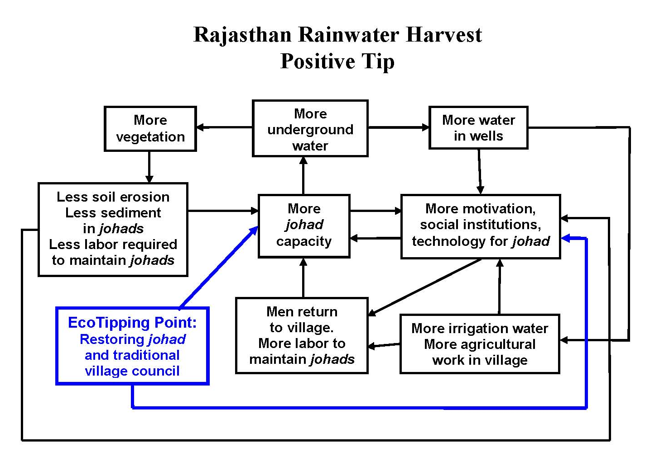

Diagram for students to fill in:
