Agroforestry and Community Forests (Nakhon Sahon, Thailand)
It was a time when farmers from Northeast Thailand were moving into this relatively uninhabited region, seeking a better life. Commercial logging concessions opened up new land for farming, accommodating landless families and a growing population. The process was accelerated by expanding domestic and foreign markets for timber, rice, maize, and cassava, accompanied by government policies that encouraged agricultural exports in order to increase government revenues.

Nakhon Sahon seemed a land of opportunity, but soon the landscape and the community were caught in a downward spiral that threatened to close off the prospects for a better life the settlers had sought. It happened because of a chain of events initially set in motion by expanding markets for timber and cash crops (see diagram below):

- Expanding agricultural markets encouraged a shift from subsistence polyculture to monocultures of the most profitable cash crops.

- Monoculture encouraged mechanization and a diminishing role for traditional draft animals (which provided manure).

- Cash cropping encouraged multiple cropping (i.e., more than one crop a year), meaning more time devoted to farm work and less time to contribute to the community support system.

- Chemical fertilizer use was increased to achieve higher yields and compensate for a diminished supply of animal manure. Chemical pesticide use increased because monocultures generally have more severe pest problems than polycultures.

- Farm land fertility declined due to intensive use, soil erosion, and chemical burden in the soil.

- Family food expenses increased as cash cropping provided less food for home consumption.

- Debt increased due to expenses for chemical fertilizers, pesticides, mechanical tillage, and a generally perceived need for greater material consumption, along with increasing family expenses for food, medicine, and other essential commodities.

- Farmers expanded the amount of land they were farming to earn more money to cover increasing expenses for agricultural inputs and service their debts. Debt also increased the need for income from commercial logging and stimulated overexploitation of forest products.

- Deforestation increased soil erosion and reduced the hydrological integrity of the watershed, reducing infiltration of rainwater to subsurface aquifers. Water shortages threatened the viability of human settlements while reducing agricultural production and the quantity and diversity of forest products for sale or home consumption.

- A less reliable water supply and more floods from a deteriorating watershed, greater dependence on food purchases for family consumption, and deterioration of the community support system eroded food security, financial security, and resilience to stresses such as downturns in farm income due to bad weather or market fluctuations.

- Debt forced able-bodied men (and later women) to migrate to cities, at first seasonally and later year-round, seeking work to supplement family incomes. This eroded community solidarity and traditional support systems, while increasing the cost of farming as it became necessary to mechanize further or hire labor from outside the family.

- Community fragmentation and impoverishment increased usury and debt, along with dysfunctional social behavior such as thievery.

- The result was an interconnected system of mutually reinforcing vicious cycles that drove the landscape and the community into progressively greater decline.

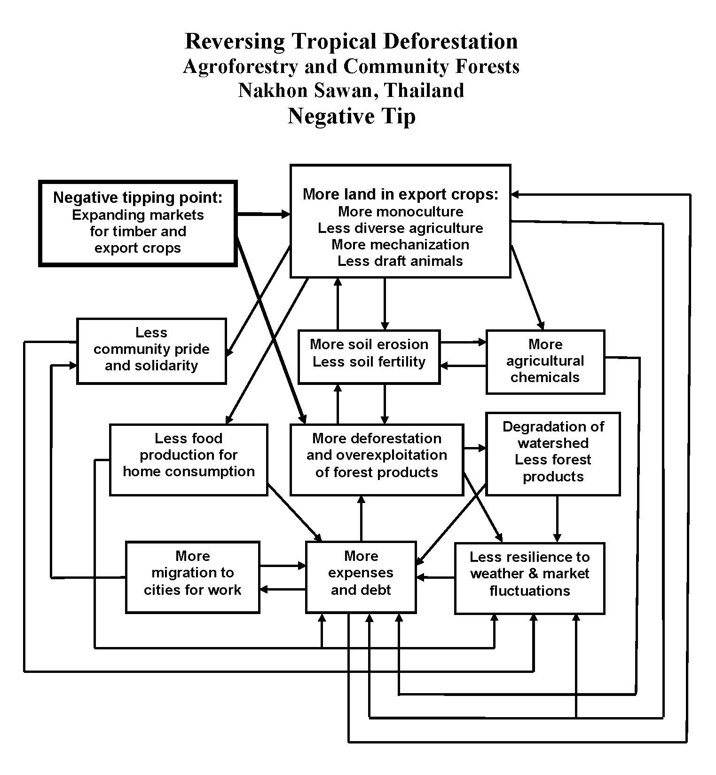

Diagram for students to fill in:
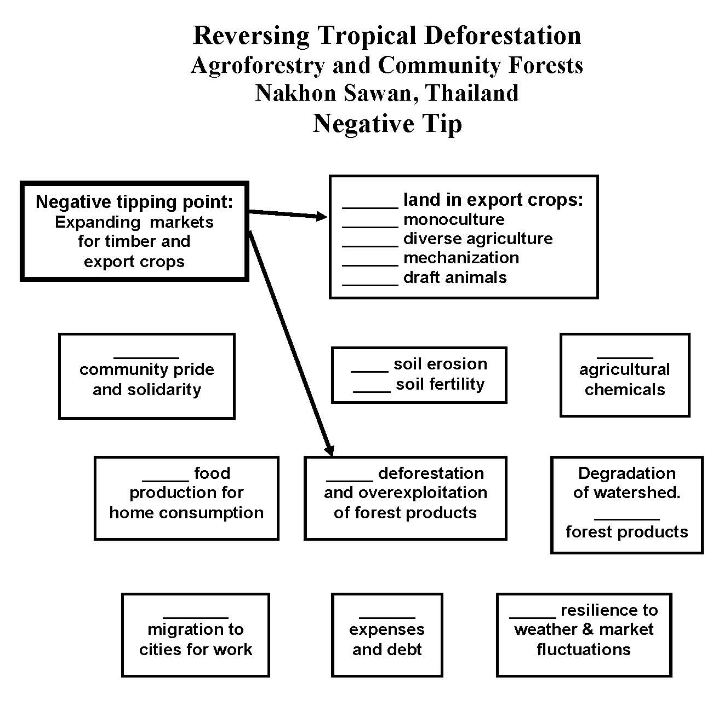
The positive tipping point was the introduction of agroforestry and establishment of a community protection forest accompanied by a process of community dialogue and problem solving that enabled successful implementation.

Agroforestry offered the following benefits:

- More income and opportunity for debt reduction if the agroforestry was commercially successful.

- “Weeds” around tree crops protected the soil from erosion and helped maintain soil fertility.

- Diversity of agroforestry provided both cash crops and food for home consumption.

- Less mechanization and a greater role for draft animals and their manure reduced the need for chemical fertilizer.

- Less chemical fertilizers and pesticides reduced input costs.

- Lower labor inputs associated with agroforestry allowed time to contribute to the community support system.

- The diversity of agroforestry was more resilient to weather and market fluctuations.

- Maintaining a protection forest as an integral part of the landscape provided:

- A healthy watershed for reliable water supply, protection from soil erosion, and flood prevention.

- A more secure supply of forest products for cash and home consumption.

- Reversal of vicious cycles in the negative tip transformed them into virtuous cycles that fostered and sustained a healthier and more productive landscape and an economically and socially healthier community.

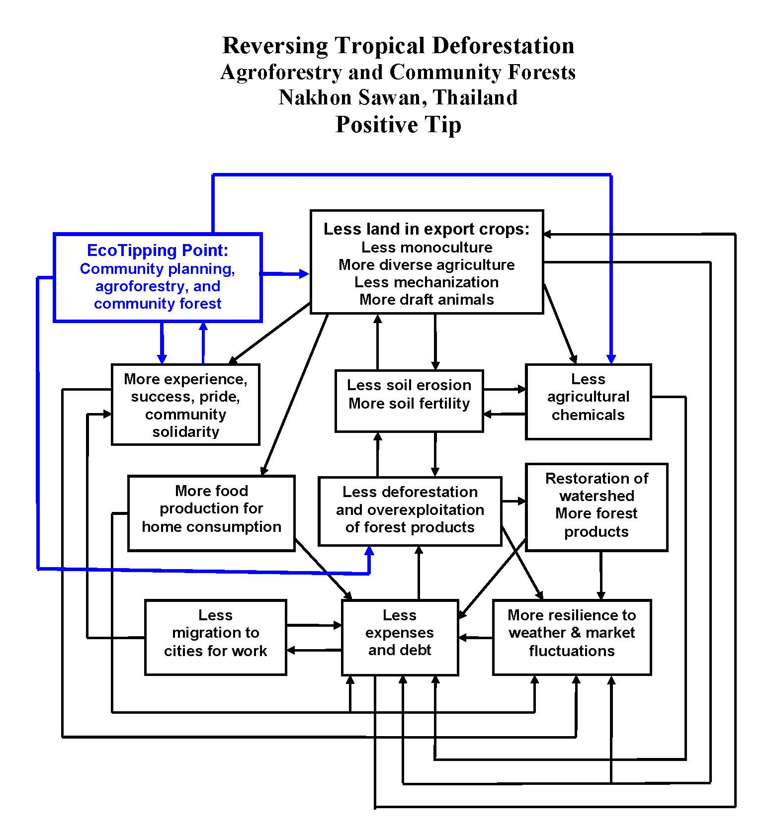

Diagram for students to fill in:
