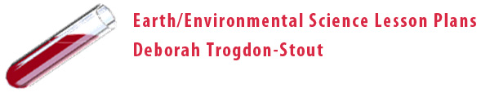

To Diaper or Not

Grade Level (Appropriate for 9-12 and AP Environmental)

Overview:

The environmental impact of disposable diapers is a debate, which can be discussed at any grade level as awareness to the environmental landfill problems of today. Using the diaper as a tool and man’s technology to create a simpler method of waste disposal, this lesson is best used with the framework of Dr. Gerry Marten’s research in EcoTipping Points.

Students will utilize their powers of observation and research to lead in discussions of various environmental issues and problems surrounding municipal waste disposal.

Objectives (students will be able to):

- List the materials used in disposable diapers
- List the functions of disposable diapers.
- Identify the environmental problems surrounding the case of disposable diapers in landfills, soil contamination, water contamination, etc.

Materials and Procedures:

- Obtain one clean unused disposable diaper per group
- Paper cup or beaker with ½ cup of water
- Construct a chart of diaper functions and a list of diaper materials
- Dissect the disposable diaper (students may want to wear goggles and a mask for protection from resin and fibers)
- Cut a 2 inch square from the diaper and place in the cup of water – observe and record reaction

Critical Thinking:

- What is the impact of these diapers in landfills?
- What is the meaning of impermeable?
- Can a better disposable diaper be made that has less impact on the ecosystem?
- What is our responsibility in the manufacturing of “convenient” materials for our daily lives and the impact these materials have on the environment?
- Discuss the chemical processes that are involved in developing disposable diapers and their environmental impact.

